Remote Learning - Information for Parents and Students
23 March 2020
Compass (robinvalep12college-vic.compass.education) is the Portal for Robinvale College students to access remote learning during any periods of non-attendance such as due to COVID19 measures.
Students log into Compass with their College username (eg SMI0003) and password.
They can access their email with the same username and password, at webmail.robinvale.vic.edu.au
Parents have their own Compass Portal username and password, issued when their first child enrols at Robinvale College. If you have lost your username or password, please email itsupport@robinvale.vic.gov.au or log an IT request at www.robinvale.vic.edu.au/contact-us

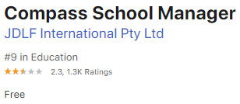
The Compass Education App can be installed from Google Play (Android) or App Store (Apple) for mobile devices.
Once installed, your username and password only needs to be entered once, the first time you log in.

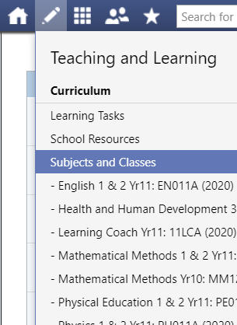
Each class in which a student is enrolled can be found on both the Portal and App. By clicking on the class, students and parents can see lesson plans, learning tasks and resources.
Class teachers can be emailed directly from the Portal or App.

Senior students may also use Webex Teams for videoconferencing with teachers. If this is the case, your class teacher will inform you. Webex Teams can be installed on any device. Log in with your college email address.

Tip: If you are using the Compass Mobile App and cannot find a function that you require, tap the menu (3 lines at top left of screen) and tap “Open in Browser” to gain full functionality.

Please keep monitoring the Compass Portal Newsfeed, the Robinvale College Facebook page (www.facebook.com/RobinvaleCollege) and the College website (www.robinvale.vic.edu.au) for updated information as it becomes available.

Graeme Smyth
Assistant Principal

